**UNIVERSITY OF CALICUT**

**CENTRE FOR COMPUTER SCIENCE AND**

**INFORMATION TECHNOLOGY**

**THALIKULAM-680569**

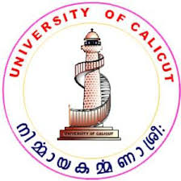

**A PROJECT WORK**

**PRODUCTION COMPANY MANAGEMENT**

*Submitted to the University of Calicut in partial fulfillment of the requirement for the award of the degree*

*Of*

**MASTER OF COMPUTER APPLICATION**

**BY**

**SREELAKSHMI N.R (TTAPMCA015)**

*Under the Guidance of*

**Mrs. Sangeetha K.S**

**(M.Sc)**

*Lecturer, Centre for Computer Science and Information Technology, Thalikulam*

**PROJECT REPORT 2015-2018**